Laplacian Image Enhancement
Code:
import cv2
import matplotlib.pyplot as plt
image = cv2.imread('top.jpg', cv2.IMREAD_GRAYSCALE)
laplacian = cv2.Laplacian(image, cv2.CV_64F, ksize=3)
laplacian = cv2.convertScaleAbs(laplacian)
enhanced_image = cv2.addWeighted(image, 1.0, laplacian, -1.0, 0)
plt.figure(figsize=(15, 5))
plt.subplot(1, 3, 1)
plt.title("Original Image")
plt.imshow(image, cmap='gray')
plt.axis('off')
plt.subplot(1, 3, 2)
plt.title("Laplacian Filtered Image")
plt.imshow(laplacian, cmap='gray')
plt.axis('off')
plt.subplot(1, 3, 3)
plt.title("Enhanced Image")
plt.imshow(enhanced_image, cmap='gray')
plt.axis('off')
plt.show()
Code Explanation:
- Load the Image:
  - cv2.imread('top.jpg', cv2.IMREAD_GRAYSCALE) reads the input image "top.jpg" in grayscale. This simplifies computations and focuses on intensity variations.
- Apply Laplacian Filter:
  - cv2.Laplacian(image, cv2.CV_64F, ksize=3) computes the Laplacian of the image, which is the second derivative. This highlights regions of rapid intensity change (edges).
  - cv2.convertScaleAbs(laplacian) converts the result to an absolute 8-bit image for proper visualization.
- Enhance the Image:
  - cv2.addWeighted(image, 1.0, laplacian, -1.0, 0) combines the original image with the negative of the Laplacian-filtered image. This effectively sharpens the image by emphasizing edges.
- Visualization:
  - The original image, the Laplacian-filtered image, and the enhanced image are displayed side by side using matplotlib.pyplot.
output:
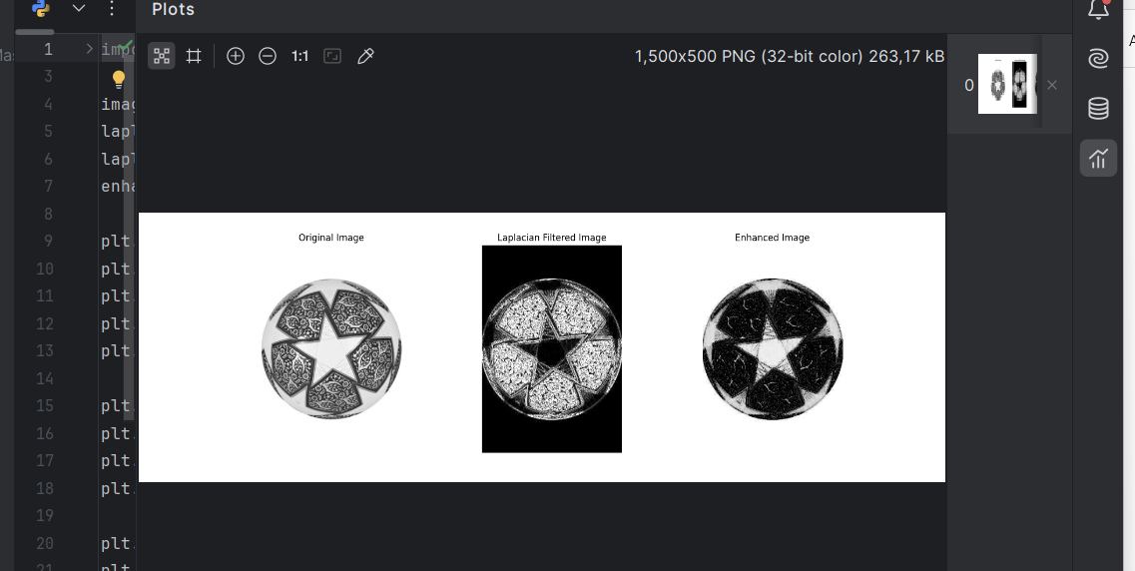
Report
Objective
To enhance the image "top.jpg" by applying the Laplacian filter and combining it with the original image for sharpening and detail enhancement.
Methodology
- The Laplacian filter, a second-order derivative method, was applied to detect edges and highlight areas of rapid intensity change.
- The Laplacian-filtered image was subtracted from the original image to sharpen details and enhance edges without losing the overall structure.
- The enhancement was performed using the formula: Enhanced Image=Original Image+(−1×Laplacian Filtered Image)\text{Enhanced Image} = \text{Original Image} + (-1 \times \text{Laplacian Filtered Image})Enhanced Image=Original Image+(−1×Laplacian Filtered Image)
Results
- Original Image:
  - Served as the baseline for comparison and enhancement.
- Laplacian Filtered Image:
  - Highlighted edges and fine details. However, the result by itself appeared too harsh due to high-frequency amplification.
- Enhanced Image:
  - Combined the sharpness from the Laplacian filter with the original image, resulting in a well-balanced, sharpened output.
  - Fine details were more prominent, and edges were more defined.
Applications
- Sharpening photographs in digital imaging.
- Enhancing features in medical images, satellite imagery, or microscopic visuals.
- Preprocessing for object recognition and segmentation tasks.
Advantages
- Enhances edges effectively while retaining the overall structure.
- Computationally efficient for real-time applications.
Limitations
- The method is sensitive to noise, as noise is also amplified along with edges. Pre-smoothing with a Gaussian filter can mitigate this.
Conclusion
The Laplacian Image Enhancement technique successfully sharpened the image "top.jpg" by emphasizing edges and fine details. Adjustments to weights or pre-smoothing could further refine results depending on the noise level in the image.

